High speed drinking paper straw making machine with 6 cutters

Samples:

Use:
This paper straw making Machine is suitable for producing different sizes of paper straws, such as 5mm; 6mm; 8mm; 10mm,12mm etc.With upgrade design for cutting device, before with 5 cutting knives, now we upgrade with 6 cutting knives, the speed will be 5 meters higher than before, the stable working speed: 34-45m/min.

Features:
1. Adopted with human-machine operation interface, main motor is equipped with variable frequency speed regulation, Easy for parameters setting & operating.
2. Paper reeling stand, slitting rolls are easily placed into reel stand by electric lifting device.
3. Choose single or double glue coating unit.
4. Spiral winding part, hanging type operation panel, specialized operation system, belt tension device(hand wheel driven)
5. Multi-knife system in-line cutting unit controlled by encoder, cutting final paper tube directly.
6. Main parts: servo motor and inverter all use Schneider brand,Pneumatic components use AirTAC brand,with very stable performance.

Technical Parameter
Paper layer | 2-5 layers
Inner diameter | 4-12mm
Thickness | 0.3-1mm
Speed | If with 5 cutters, the stable working speed is 30-40meters/ minute  If with 6cutters, the stable working speed is 35-45meters/ minute
Cutting system | Program control multi knife
Cutting length | 120- 1050mm
Synchronous tracking and cutting | Servo motor synchronous tracking cutting
Way Of Gluing | Single /Double Side
Fixed length way | Encoder
Operator | 1 person
speed control | Pole free speed regulation
Fuselage parts | 380v/3phase/50Hz
paper stand | 3 layers
Glue System | Three layer spray type
Fuselage parts | Medium carbon iron plate /Stainless steel
Control system
Electric machinery | Dedong Shanghai
Interface | Schneider
Inverter | 4kw Schneider
Actuating element | Schneider
Signal element | OMCH
Pneumatic components | AirTAC
Electrical components | Schneider
Bearing | HRB
Servo Motor | 1kw Schneider
Moving wire rod | ABBA Taiwan
Moving slider | ABBA Taiwan
Size
Main Part Dimension | 5600*1600-1750mm
Overall Dimension | 8000*6000* 1800mm
Weight | 1200kgs

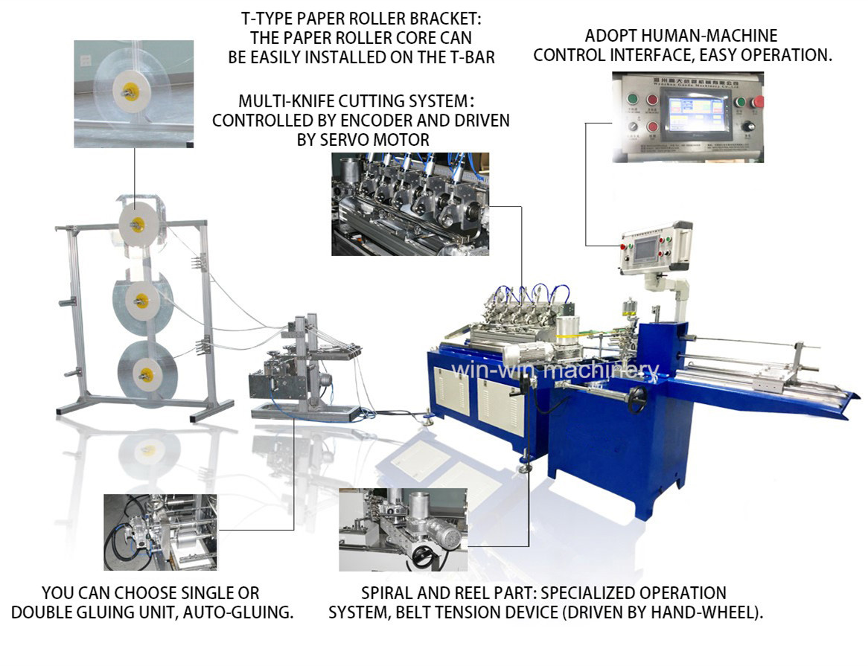

Detailed photos for parts
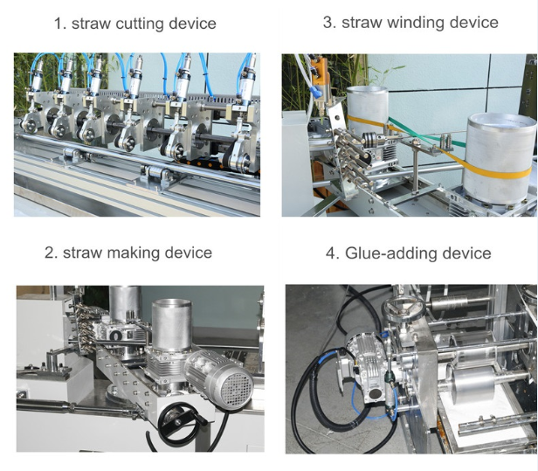

The machine with 5 cutters
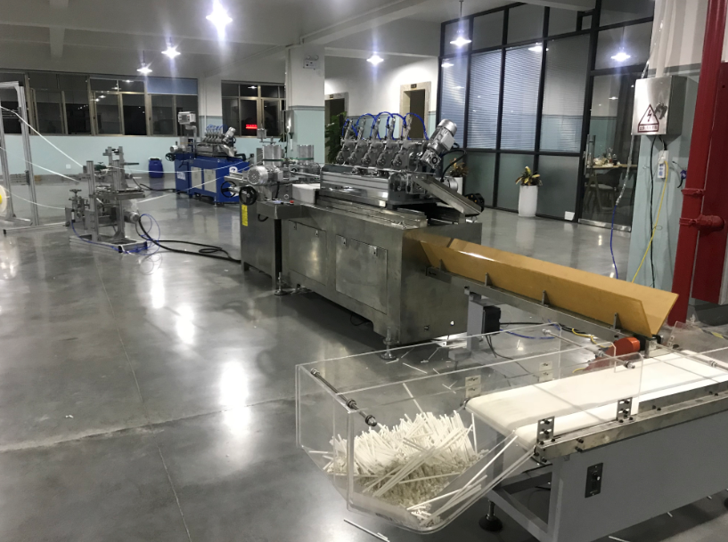

The machine with 6 cutters
